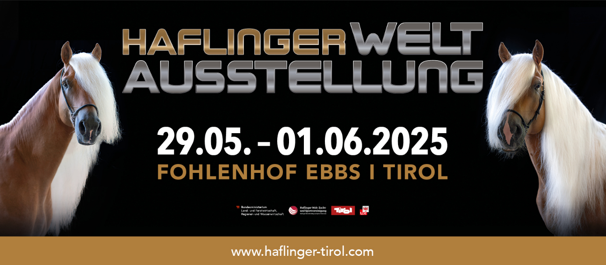

**THE PROGRAMME**

**Tuesday, 27 May 2025 and Wednesday, 28 May 2025**

8 a.m. – 8 p.m. Arrival and veterinary check-up of the horses

**Thursday, 29 May 2025**

8:00 a.m. to 5:00 p.m. **Judging of the horses** in the show rings and **determination of class winners**

in the Fohlenhof Arena

6:00 p.m. **Official opening ceremony** in the Fohlenhof Arena

Welcome speeches by guests of honour, blessing of the horses, followed by the International Haflinger Show

8:00 p.m. **Tyrolean evening with ORF Radio Tirol Musiktruchn** in the

Fohlenhof Festival Hall with a buffet of Tyrolean delicacies

Alexander Weber presents: Sigrid and Marina, Markus Wolfahrt, Alexander Rier

and Sepp Mattlschweiger's Quintett Juchee

10 p.m. 3D Haflinger horse video projection under the starry sky

‘The horse – an integral part of agriculture’

Until midnight Closing with the Juchee Quintet

Admission free.

**Friday, 30 May 2025**

8 a.m. to 5 p.m. **Judging of the horses** at the show grounds and **determination of class winners** in the Fohlenhof Arena

10 a.m. to 12 noon **Radio U1 guest** at the Haflinger World Exhibition

1 p.m. to 2 p.m. Live broadcast from the Fohlenhof Festival Hall

6:00 p.m. **International Haflinger Show** in the Fohlenhof Arena

8:00 p.m. **Country Evening** in the Fohlenhof Festival Hall with barbecue specialities from the buffet

Admission free

10:00 p.m. 3D Haflinger horse video projection under the starry sky

"The horse – an integral part of agriculture’

**Saturday, 31 May 2025**

9 a.m. to 4 p.m. **Determination of the national winners, generation winners**,

overall winning mares and overall winning stallions

10 a.m. to 2 p.m. **ORF Radio Tirol on the road at Fohlenhof Ebbs**

**Der Wochenend Reporter** reports live from the Haflinger World Exhibition

6:00 p.m. **Int. Haflinger Show** in the Fohlenhof Arena

8:00 p.m. **The Austrian Evening** in the Fohlenhof Festival Hall with Austrian & international delicacies

Live guests: Die Jungen Thierseer

Admission free

10:00 p.m. 3D Haflinger horse video projection under the starry sky

‘The horse – an integral part of agriculture’

**Sunday, 1 June 2025 –** Best of the Haflinger World Show 2025

9:30 a.m. – 1:30 p.m. **Presentation of all participating countries**, **presentation of all winning mares** and **winning stallions |** Show discussion

10:00 a.m. – 1:00 p.m. **U1 morning pint** in the Fohlenhof Festhalle

Presenter Lukas Brunner introduces the Zillertaler and the violinist, the Grenzgängersound, Lumpen Mander, Romantik Express and Susal the party witch

2:00 p.m. **Int. Haflinger Show with closing ceremony**